

Year 12 Chemistry

Equilibrium Test 2022

**Time allowed: 45 minutes**

**Name:**

**Teachers: MXC BLR NMOB**

**Mark = ………/45**

# SECTION 1 MULTIPLE CHOICE (10 marks)

Questions 1 and 2 refer to the following information

Oxides of nitrogen are formed in air at the high temperatures generated in lightning flashes according to the equation

# N2(g) + O2(g) ⇄ 2 NO(g) *K*1 = 5 × 10–3 at 3000ºC

1. At 3000ºC, the equilibrium constant *K*2 for the reaction

**2 NO(g)** ⇄ **N2 (g) + O2(g)**

would be:

* 1. 4 × 104
  2. 2 × 102
  3. 1 × 10-2
  4. 5 × 10-3

1. A higher temperature in the lightning flash increases the rate of the reaction but does

**not** increase the

* 1. number of collisions
  2. fraction of reacting particles which possess energies greater than the activation energy
  3. the average velocity of the reacting particles
  4. activation energy

1. A change is made on a system at equilibrium and it is observed that the equilibrium position moves to the right (products side). Which of the following is consistent with this observation?
   1. 2 Cl2(g) + 7 O2(g) ⇄ 2 Cl2O7(g); the pressure is increased by adding Ne to the vessel at constant volume
   2. H2(g) + I2(g) ⇄ 2 HI(g); the pressure is decreased by removal of some of the HI(g)
   3. 2 H2(g) + O2(g) ⇄ 2 H2O(g); H = - 484 kJ; the temperature is increased.
   4. I2(s) ⇄ I2(g); solid iodine is added.
2. Under certain conditions, cyclohexane, C6H12, can react to form benzene, C6H6 and hydrogen according to the equation

**C6H12 (g)** ⇄ **C6H6(g) + 3 H2(g)** **H = +206 kJmol-1**

If the volume of the reaction vessel was increased at constant temperature, then:

* 1. the equilibrium concentration of cyclohexane would decrease but its mass would increase.
  2. the equilibrium concentration of cyclohexane would be unchanged but its mass would decrease.
  3. the equilibrium concentration of benzene would decrease but its mass would increase.
  4. the equilibrium concentration of benzene would increase and its mass would increase.

1. For the reaction

# Fe2+(aq) + Ag+(aq) ⇄ Fe3+(aq) + Ag(s) H = -65.7 kJ mol-1

Which of the following increases the value of the equilibrium constant, K?

* 1. adding silver ions to the system.
  2. removing water from the system.
  3. decreasing the temperature.
  4. increasing the temperature.

1. Cobalt (II) salts generally appear pink due to the presence of Co(H2O) 2+ (aq) but the tetrahedral complex CoCl 2-(aq) is blue in colour. For the reaction:

6

4

# Co(H2O) 2+(aq) + 4 Cl-(aq) ⇄ CoCl 2-(aq) + 6 H2O(l) H = + 12.4 kJ mol-1

**6 4**

Which of the following would cause the reaction mixture to take on a stronger BLUE colour?

1. adding a few drops of water
2. adding concentrated hydrochloric acid
3. adding silver nitrate solution
4. heating

V cooling

* 1. I, II and IV
  2. III and IV
  3. II and IV
  4. II and V

1. Methanol is prepared commercially by reacting CO with H2 at 400ºC in the presence of a catalyst.

# CO(g) + 2 H2(g) ⇄ CH3OH(g) ∆H = – 92 kJ mol-1

If a mixure of CO, H2 and CH3OH were at equilibrium in a sealed container and the temperature of the gases were raised, the:

* 1. total pressure of the gas mixture would decrease.
  2. rates of forward and reverse reactions would remain constant.
  3. total number of gas molecules would increase.
  4. the value of K would increase.

1. Consider the following equilibrium.

# SO3(g) ⇄ SO2(g) + O2(g) H= + 196 kJmol-1

The system is initially at equilibrium. At time **t1**, the temperature of the system was increased. Which of the following best represents the changes in the forward and reverse reaction rates until equilibrium is re-established at time, **t2**?

The forward reaction rate is represented by

The reverse reaction rate is represented by - - - - - - - - -

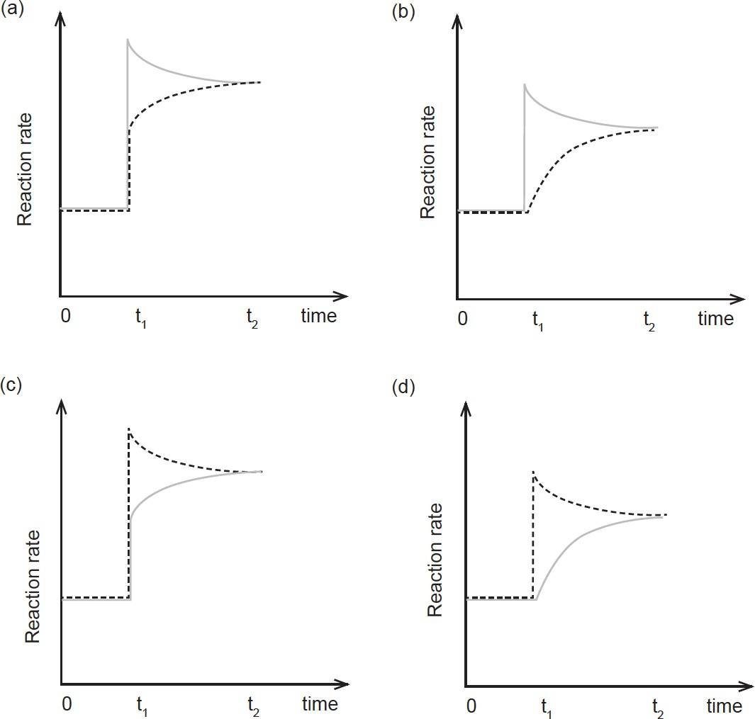

1. In which one or more of the following chemical equilibrium systems will the position of equilibrium be shifted to the left by an increase in pressure?

# CaCO3(s) ⇄ CaO(s) + CO2(g)

1. **2 HI(g)** ⇄ **H2(g) + I2(g)**

# C3H8(g) + 5 O2(g) ⇄ 3 CO2(g) + 4 H2O(g)

1. **Cl2(g) + 3 F2(g)** ⇄ **2 ClF3(g)**
   1. I only
   2. I and II only
   3. I and III only
   4. IV only
2. Hydrogen sulfide is used as a source of sulfide ions in qualitative analysis. The equations for the production of sulfide ions are:

|  |  |  |
| --- | --- | --- |
| **H2S(aq)** | ⇄ | **H+(aq) + HS-(aq)** |
| **HS-(aq)** | ⇄ | **H+(aq) + S2-(aq)** |

When acid is added to the equilibrium mixture above, the sulfide ion concentration will:

* 1. increase.
  2. remain constant.
  3. decrease.
  4. be always equal the hydrogen ion concentration.

# SECTION 2 WRITTEN ANSWERS (35 Marks)

**Question 11 (6 marks)**

The industrial production of ethanoic acid is by the Monsanto process, which is as follows;

# CH3OH(g) + CO(g) ⇄ CH3COOH(g) H = -ve

The conditions used for this process are 2000C and 3000 kPa. Outline the factors that would have been considered in choosing these as the optimum conditions. Use Le Chatelier’s Principle to justify your answers.

# Temperature

(3 marks)

# Pressure

(3 marks)

# Question 12 (15 marks)

Consider the following equilibrium;

# 4 NH3(g) + 5 O2(g) ⇄ 4 NO(g) + 6 H2O(g) H = –908 kJ

1. For each of the following changes, predict the effect on the value of the equilibrium constant (K), the rate of the forward reaction, the concentration of oxygen (O2) and the mass of nitrous oxide (NO) once equilibrium has been re-established. Identify the changes as **increase, decrease** or **no change.**

|  |  |  |  |  |
| --- | --- | --- | --- | --- |
| Change | K | rate of forward reaction | [O2] | mass of NO |
| Increase temperature |  |  |  |  |
| Remove some NH3 |  |  |  |  |
| Add a catalyst |  |  |  |  |
| Decrease the volume of the container |  |  |  |  |
| Add neon gas at constant volume |  |  |  |  |

(10 marks)

1. Use collision theory to explain the effect (if any) on the concentration of O2 when the temperature of the system is increased.

(5 marks)

# Question 13 (14 marks)

Equilibrium is established between the yellow chromate ion (CrO 2–) and the orange dichromate ion (Cr2O 2–) according to the following equation.

4

7

# 2CrO 2– aq) + 2 H+(aq) ⇄ Cr O 2–(aq) + H O(l)

**4 ( 2 7 2**

Yellow Orange

Assume that an orange equilibrium mixture contains an excess of dichromate ions and a yellow mixture contains an excess of chromate ions.

1. Write an expression for the equilibrium constant for this reaction.

(1 mark)

1. Consider an equilibrium mixture of these ions.
   * At time t1 several drops of a concentrated solution of sodium hydroxide (NaOH) were added.
   * At time t2 equilibrium is re-established.
   * At time t3 Na2Cr2O7(s) was added.
   * At time t4 equilibrium is re-established.

Sketch a qualitative graph demonstrating the change in the rates of the forward and reverse reactions during these events until equilibrium is re-established at t4. From t=0 to t = t1 the rates of the forward and reverse reactions are equal.

|  |  |
| --- | --- |
| **Rate** | Forward Reverse ----------- |
|  | **0 t1 t2 t3 t4 time** |

(4 marks)

# Question 13 continued

Water is now added to an equilibrium mixture of chromate and dichromate ions which was orange in colour so that its volume is doubled.

1. Give an observation predicting the colour change(s) you would observe (if any).

(2 marks)

(d)(i) On the axes below show the relative concentrations of the chromate and dichromate ions in equilibrium before the water is added at t1.

(ii) Sketch a qualitative graph of the concentration of the chromate and dichromate ions in solution as water is added at t1 until it comes to equilibrium at t2.

|  |  |
| --- | --- |
| **Conc** | chromate dichromate ----------- |
|  | **t1 t2 time** |

(4 marks)

(e) A student wanted to prepare a solution of potassium dichromate (K2Cr2O7) but only had solid potassium chromate (K2CrO4) available. Explain how the student would do this. Explain your reasoning.

(3 marks)

**End of Test**